

Spring 2026

Name: Adil Khan
Roll no: 2610-4011
Degree: BS AI
Task no 1:
#include <iostream>
using namespace std;

class Shape {
public:
void area() {
cout << "Area of shape" << endl;
}

void display() {
cout << "This is a shape" << endl;
}
};

class Circle : public Shape {
private:
double radius;

public:
Circle(double r) {
radius = r;
}

void area() {
cout << "Area of Circle: " << 3.1416 * radius * radius << endl;
}

void display() {
cout << "Circle with radius: " << radius << endl;
}
};

class Rectangle : public Shape {
private:
double length, width;

public:
Rectangle(double l, double w) {
length = l;
width = w;
}

void area() {
cout << "Area of Rectangle: " << length * width << endl;
}

void display() {
cout << "Rectangle with length: " << length
<< " and width: " << width << endl;
}
};

int main() {
Circle c(5);
Rectangle r(4, 6);

c.display();
c.area();

cout << endl;

r.display();
r.area();

return 0;
}

Output:
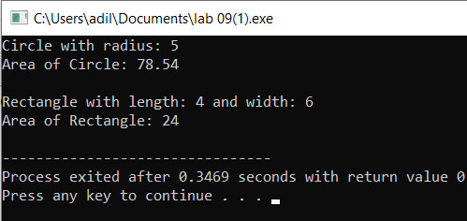

Task no 2:
#include <iostream>
using namespace std;

class Shape {
public:
virtual void area() {
cout << "Area of shape" << endl;
}

virtual void display() {
cout << "This is a shape" << endl;
}
};

class Circle : public Shape {
private:
double radius;

public:
Circle(double r) {
radius = r;
}

void area() override {
cout << "Area of Circle: " << 3.1416 * radius * radius << endl;
}

void display() override {
cout << "Circle with radius: " << radius << endl;
}
};

class Rectangle : public Shape {
private:
double length, width;

public:
Rectangle(double l, double w) {
length = l;
width = w;
}

void area() override {
cout << "Area of Rectangle: " << length * width << endl;
}

void display() override {
cout << "Rectangle with length: " << length
<< " and width: " << width << endl;
}
};

int main() {
Shape* ptr;

Circle c(5);
Rectangle r(4, 6);

ptr = &c;
ptr->display();
ptr->area();

cout << endl;

ptr = &r;
ptr->display();
ptr->area();

return 0;
}

Output:
